**NAME: AQSA TAUHEED (2303.KHI.DEG.011)**

**PAIRING WITH : MAVIA ALAM KHAN (2303.KHI.DEG.017)**

**&**

**MOHAMMAD HUSSAM(2033.KHI.DEG.020)**

**ASSIGNMENT 4.2**

Start Kafka using docker-compose and:  
1. Create a topic.  
2. List Kafka topics.  
3. Inspect one of them to see the number of partitions.

**SOLUTION:**

**STEP 1:**

First we created docker-compose.yml file . This docker-compose file sets up a Kafka cluster with one broker and one Zookeeper instance. It uses the images from Confluent for Kafka and Zookeeper. The broker is exposed on port 9092, and depends on Zookeeper.

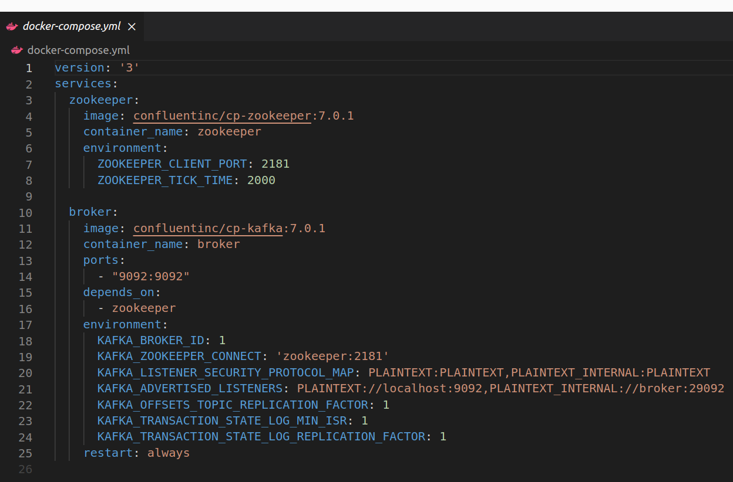

**STEP 2:**

Run the docker compose up – d command to Start the Kafka broker and ZooKeeper containers.

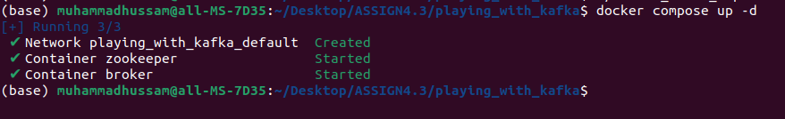

**STEP 3 :**

We Created the (create_kafka_topic.sh) file and we configured the create_kafka_topic.sh file so that it creates topics and presents a list of all topics after creating.

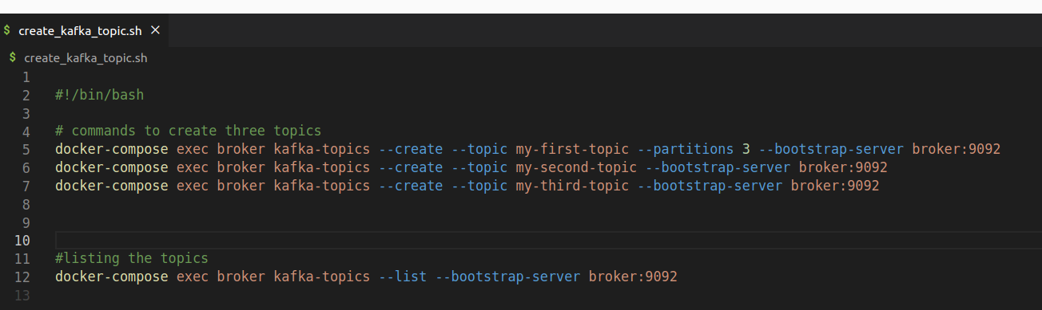

**STEP 4:**

Running create_kafka_topic.sh to run the script and display the list of all created topics.  
  
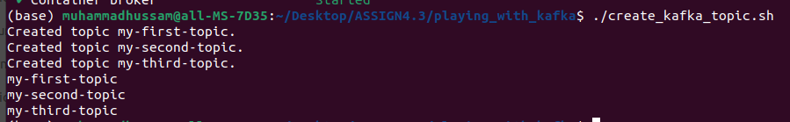

**STEP 5 :**

Inspect the "my-first-topic" topic to see the number of partitions.

